**CS-4042 MVC Web Application Step by Step**

1. Create a new .NET Web Application project and then select MVC from the Templates menu.

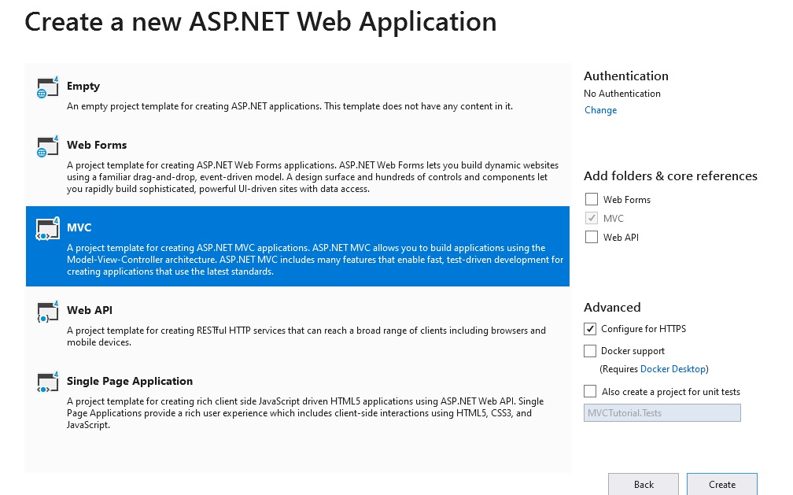

1. After you create your project, you will see several *folders in your Solution Explorer:

**View:** In this folder you will add MVC views which can be HTML , Razor or Webform pages.

**Model:** In this folder you will add model classes. Models are simple .NET classes which provides data and probably also contain validations. In this folder you will add Customer class, Supplier class etc.

**Controller:** In this folder you will add controller and controllers can have actions. This guy is responsible for taking the request from the end user, invoking the appropriate actions, creating object of the model and then tieing up the view and model together to send the results as response.

**App_Start:** Before the MVC application comes live it need lot of objects to be activated and initialized. For example routing , bundling and minification components etc.

Content: This folder has CSS(Cascading style sheet) which gives a uniform look and feel for your project.

**App_Data:** App_Data is for file based data store. Normally developers use RDBMS like SQL Server, oracle etc but some time people use XML, txt files to store data. So this folder is created when you store data in files.

1. Right click on Model folder in Solution Explorer and add a new class.

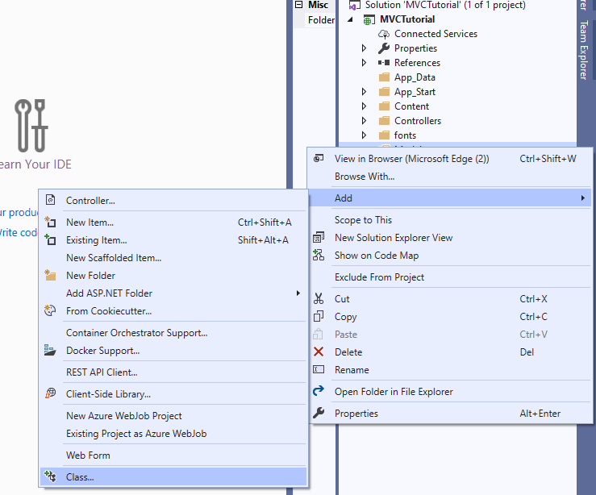

1. Create two properties in the User class (refer to the code provided).
2. Click on the Controller folder in Solution Explorer and add a new Controller. Note that you must always use the term *Controller* as suffix in the name.

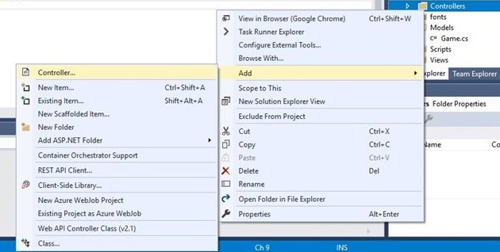

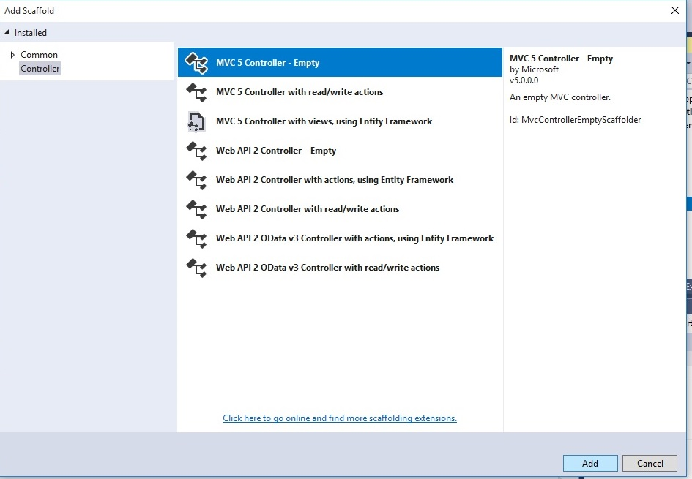

1. Now you can create different actions in your Controller code. (Refer to the code provided).
2. Right click on the Views folder and add a new View from the menu. Note that this view must have the same name as the function/action you defined in your Controller’s code. The idea here is that for each action a view is defined.
3. After renaming it. You would want to use an existing layout for the page

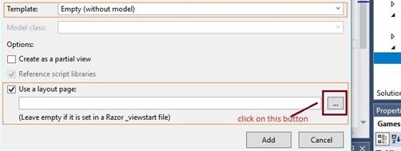

1. Select the layout file *_Layout.cshtml* and press OK.
2. Now modify the code of your view (refer to the code provided). And run the application (F5).

* Good resource: <https://www.codeproject.com/Articles/207797/Learn-MVC-Model-View-Controller-step-by-step-in>